**Wave equation**: **v = λf**

**v** = **velocity** (m/s) **f** = **frequency** (Hz *or* per second *or* 1/s) **λ** = **wavelength** (m)

1. Fill in the table by filling in all the blanks

| Formula (unknown on the left) | Velocity (v) | Wavelength (λ) | Frequency (f) | Substitutions |
| --- | --- | --- | --- | --- |
| v = λf | *80 m/s* | 10 m | 8 Hz | *v = (10m)(8 Hz)* |
| v= λf | 6m/s | 3 m | 2 Hz | v=(3m)(2Hz) |
| λ=v/f | 10 m/s | 2m | 5 Hz | λ=10/5 |
| f=v/λ | 20 m/s | 5 m | 4Hz | f=20/5 |

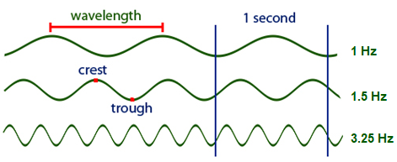

**Use this drawing to answer questions 1-5**

|  |
| --- |

1. In the above drawing 1 Hz, 1.5 Hz, 3.25 Hz represents the *frequencies* of the waves. (*wavelengths*, *speeds* or *frequencies*)
2. What does the frequency of 1.5 Hz tell us about the wave (what does Hz mean in a sentence)?

Hz refers to the number of cycles in a wave occurring per second.

1. Use a ruler and measure in centimeters how long the wavelength is for each of the three waves. (I did this for you)
   1. 3.0 cm
   2. 2.0 cm
   3. 0.8 cm
2. As the frequency increased, what happened to the wavelength? The wavelength decreased as the frequency increased
3. Using the measured wavelengths and frequencies find the speed of each wave in cm/s (*show your work by including the equation, substitutions and units*)
   1. λ= .03m f=1Hz v=? v=λf v=(.03)(1) v=0.03m/s
   2. λ=.02m f=1.5Hz v=? v=λf v= (.02)(1.5) v=0.03m/s
   3. λ=.008m f=3.25Hz v=? v=(.008)(3.25) v=0.026m/s
4. What is the wavelength of a sound wave with a frequency of 50 Hz? (Speed of sound is 342 m/s)(*show your work by including the equation, substitutions and units*)

λ=v/f v=342m/s f=50Hz λ=342/50 λ=6.84m/s

1. A sound wave in a steel rail has a frequency of 620 Hz and a wavelength of 10.5 m. What is the speed of sound in steel? (*show your work)*

*v=*λf λ=10.5m f=620Hz v=(10.5)(620) v=6510m/s

***Use the images below to answer the following questions:***

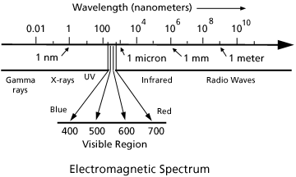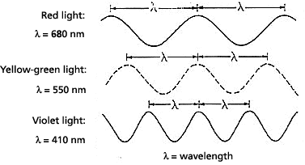

1. A *nano* is one billionth. Write one billionth as a fraction 1/1000000000
2. Write one billionth as a decimal (you will need to move the decimal point nine times to the left). 1 x 10−**9** and as a power of ten: 1 x 10___
3. The wavelength of red light is 680 nm (nm stands for nano meters ).

Convert 680 nm into scientific notation for meters. 680 nm = 6.8 x 10−**7** m

1. All light travels at the same speed of 3x108 (300,000,000) m/s. Using the information above calculate the frequency for red, yellow-green and violet light.

| Color of light | Formula | Substitutions | Frequency (f) |
| --- | --- | --- | --- |
| Red | *f=v/*λ | f= (3x10^8)/(6.8x10^-7) | f=4.41x10^14Hz |
| Yellow-green | *f=v/*λ | f=(3x10^8)/(5.5x10^-7) | f=5.45x10^14 |
| Violet | *f=v/*λ | f=(3x10^8)/(4.1x10^-7) | f=7.32x10^14 |

1. Which light has the highest frequency? Violet light
2. Higher frequency means more energetic, which color of light is the most energetic? Violet light Which is the least energetic? Red light